Digital Filtering
Project 1 : FIR
Ravi Teja Chinta, 1851-1017

This project deals with the design of a lowpass filter for a communication system. Given the passband and stopband specifications, lowpass filters are designed using three different techniques: Windowing, LMS and Equiripple. Each technique has further flavors. Filters are designed using filter design functions from the Signal Processing Toolbox in MATLAB. The project has 6 parts. The first three parts involve design and analysis of the filters and the next three parts are to test the filter - more at an implementation point of view.
PART I, Window Method
a. Function used: fir2(N,F,A)
Order of the filter = 31; N=30
F=[0 0.3 0.4 1]; A = [1 1 0 0];

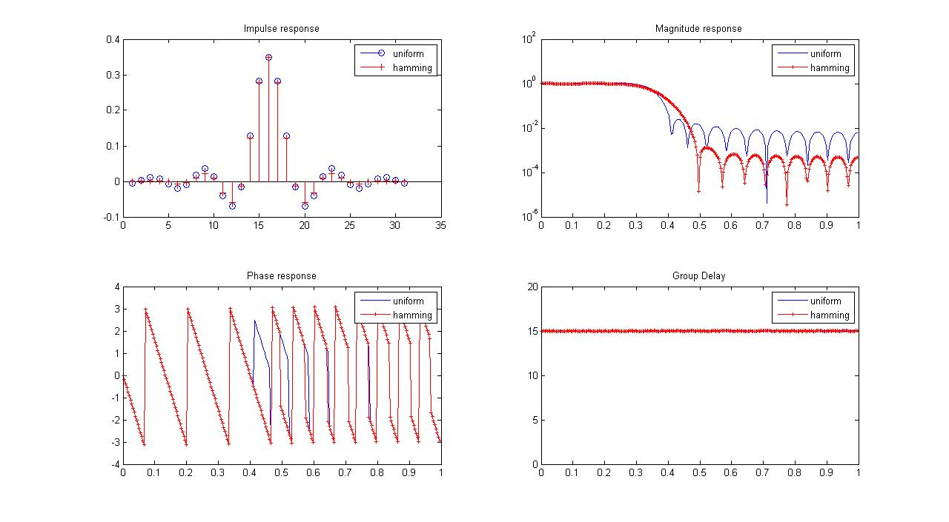

Fig 1: Uniform vs Hamming : Impulse response, Magnitude response, Phase response, group delay

Fig 1 summarizes the analysis of the effect of Uniform and Hamming Windows used in Windowing technique. The impulse response is of order 31 and symmetric about sample 16. Phase response is linear and the group delay plot corroborates this result. The group delay for both the filters is 15 as the theory predicts. The transition band for the Hamming windowed filter is larger but it is smoother in the passband and also has a larger attenuation in the stopband.

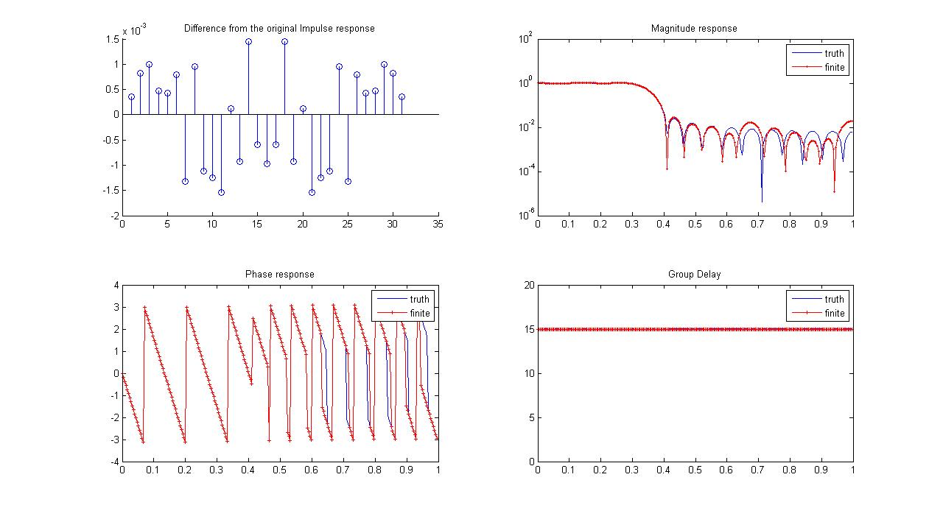Fig 2: Uniform windowed FIR: Truth vs Finite precision. Impulse response, Magnitude frequency response, Phase response and Group delay.

Fig 2 captures the effect of precision. The filter used is Uniform windowed filter and the coefficients are truncated to 8 bits, thereby resulting in minor errors. The impulse response for the finite precision case hasn't deviated much from the original impulse response. The differences in the magnitude response can be be noticed in the stopband but not significant. The phase response however deviates slightly from the original linear phase behavior.

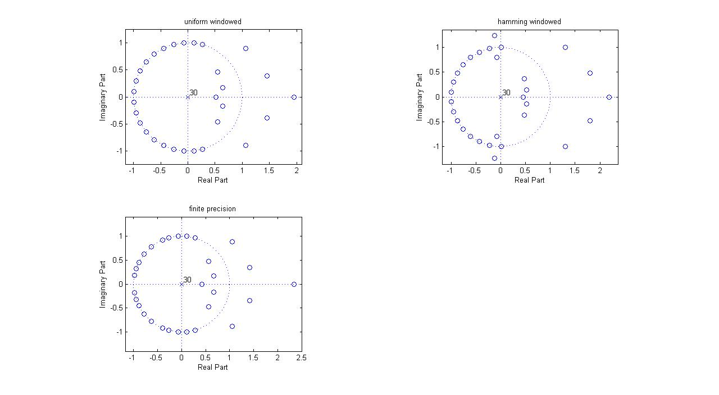

Fig 3: Pole Zero plot for the three cases of filters discussed above
Zeros for the finite precision case are almost at the same location as the true value case. As you can see from the figure the zeros outside the unit circle have come closer to the circle and also the ones on the real axis.

PART II, LMS Method
Function used: firls(N,F,A)
Filter order: 31; N= 30
F=[0 0.3 0.4 1]; A=[1 1 0 0];
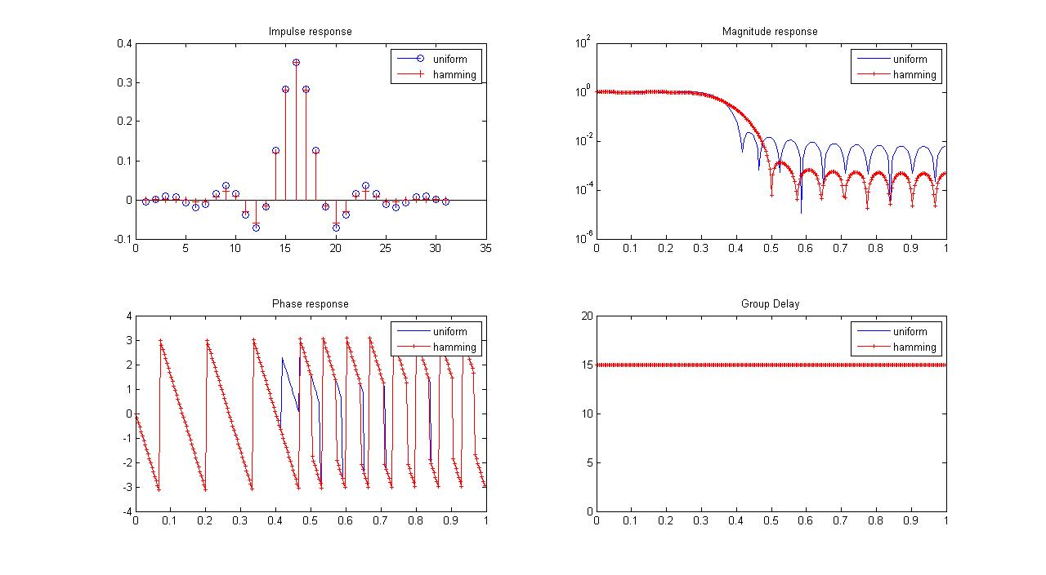Fig 4: LMS filters: Uniform and Hamming windows. Impulse response, Magnitude response, Phase response, and group delay
Again as with the Hamming window property, the magnitude response has a larger transition band but a smoother passband and larger attenuation in the stopband. The phase response for both the filters is linear and the group delay is 15.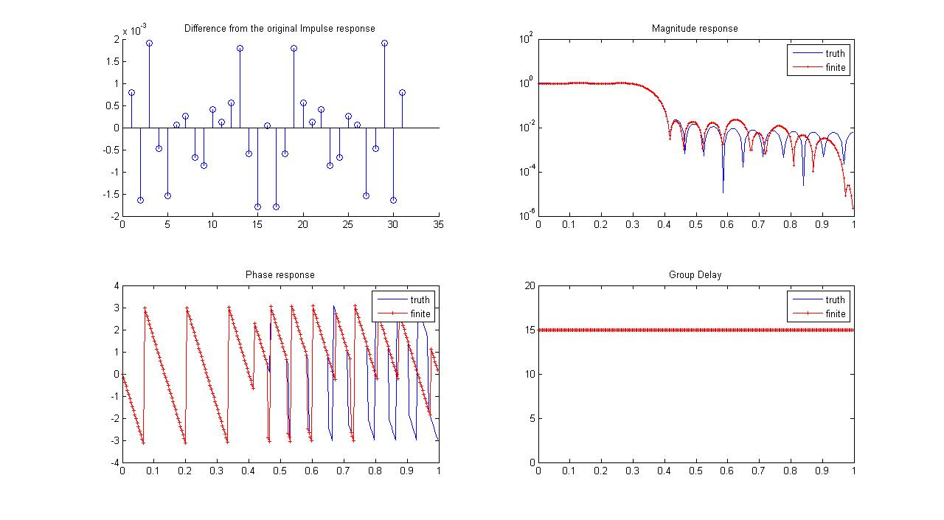

Fig 5: LMS filters: Finite precision vs truth. Difference in impulse responses, magnitude response, Phase response and group delay
The difference in true impulse response and finite precision impulse response is shown here and it can be noted as small. The magnitude frequency response is almost, as shown is the figure above.

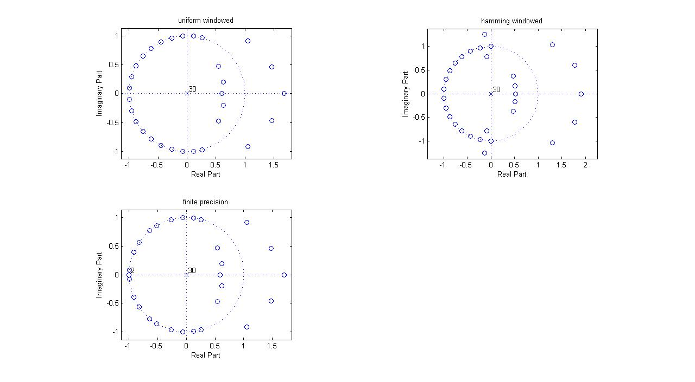

Fig 6: LMS Filters: Zero - pole locations of Uniform windowed, Hamming windowed and finite precision filters
The above figure shows the zero locations for the above filters.
PART III
Function used:firpm(N,F,A,W)
Filter order: 31; N = 30
F = [0 0.3 0.4 1]; A = [ 1 1 0 0]; W = [1 1] and [1 25/16];

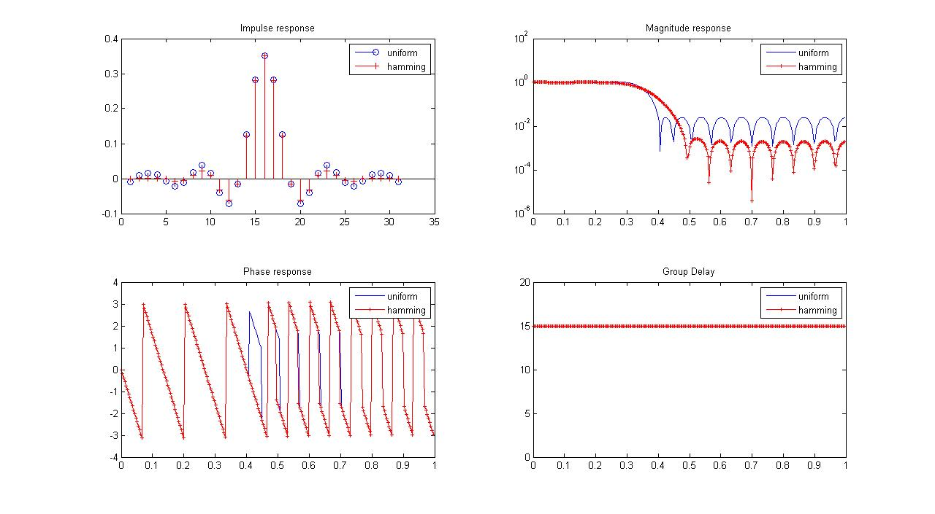

Fig 7: Equiripple filters. Comparision between uniform weighted, uniform windowed and hamming windowed filters
The transition band is larger for the Hamming window case, stopband attenuation is smaller and passband is smoother when compared to the uniform window.

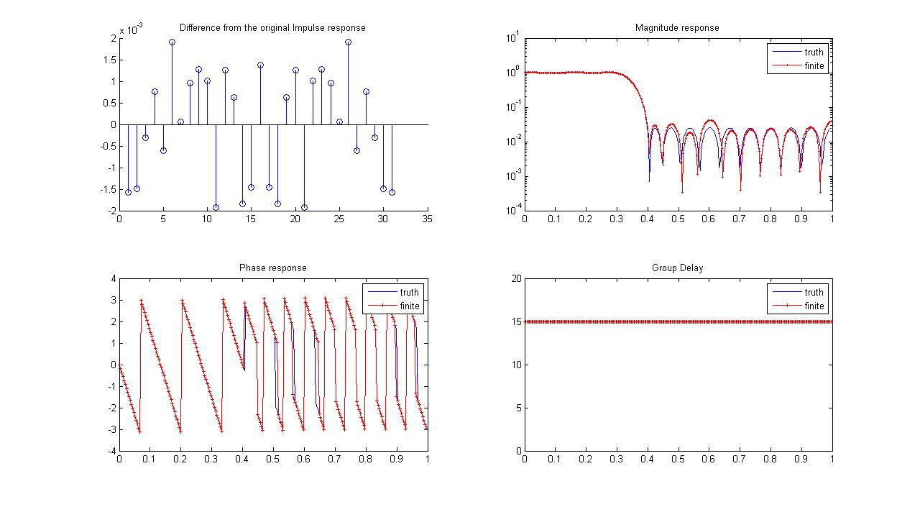

Fig 8: Equiripple filters. Comparision between uniform windowed, uniform weighted true and finite precision filters.

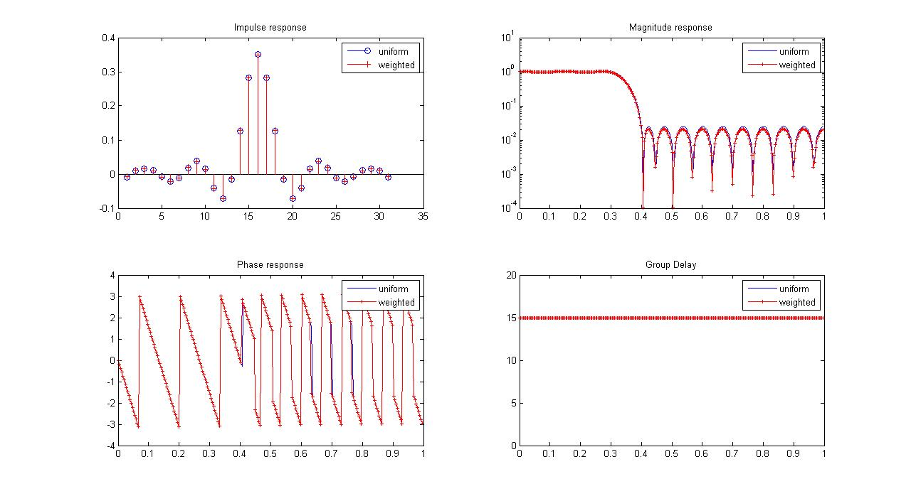

Fig 9: Equiripple filters: Comparision between Uniform windowed, uniform and non-uniform weighted filters
delta_p1 = delta_a1 and delta_p1*delta_a1 = delta_p2*delta_a2.
delta_a2 decreases by 20% which means delta_a2 = delta_a1*4/5
so delta_p2 increases to delta_p1*5/4 to satisfy the relation
so W_a/W_p = delta_p2/delta_a2 = 25/16
that is the stopband errors are to be weighted 25/16 times more than the passband errors.
so W = [16 25] or [1 25/16]
From the figure above you can see a marginal change in the stopband attenuation, about a dB.

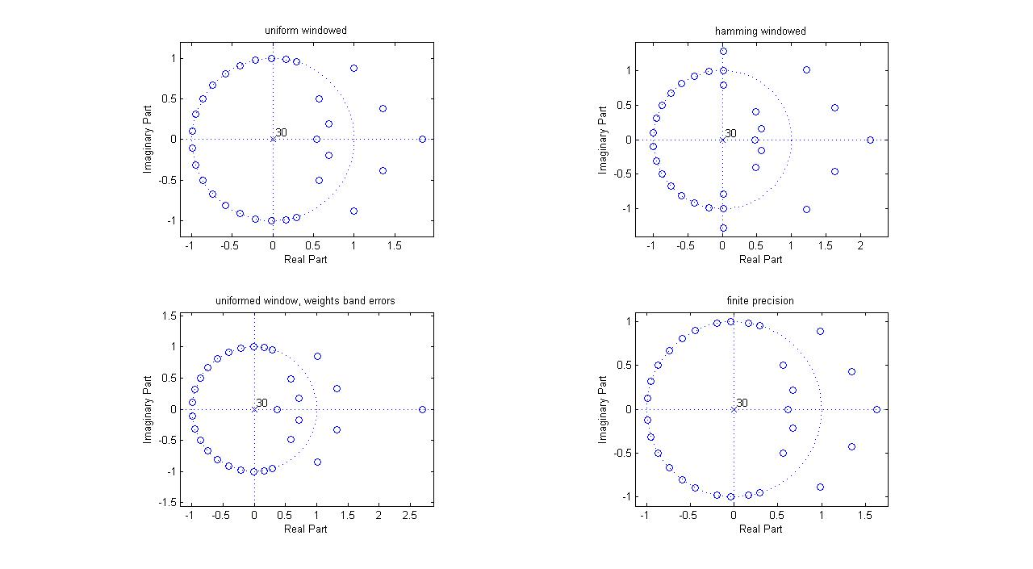

Fig 10: Equiripple filters: Pole - zero locations for the four filters discussed above

As the stopband attenuation is increased the zeros outside side the unit circle and their complex conjugates seems to move towards the unit circle radially except the ones on the real line which go away from the circle - for the uniform window case.
Part IV, testing
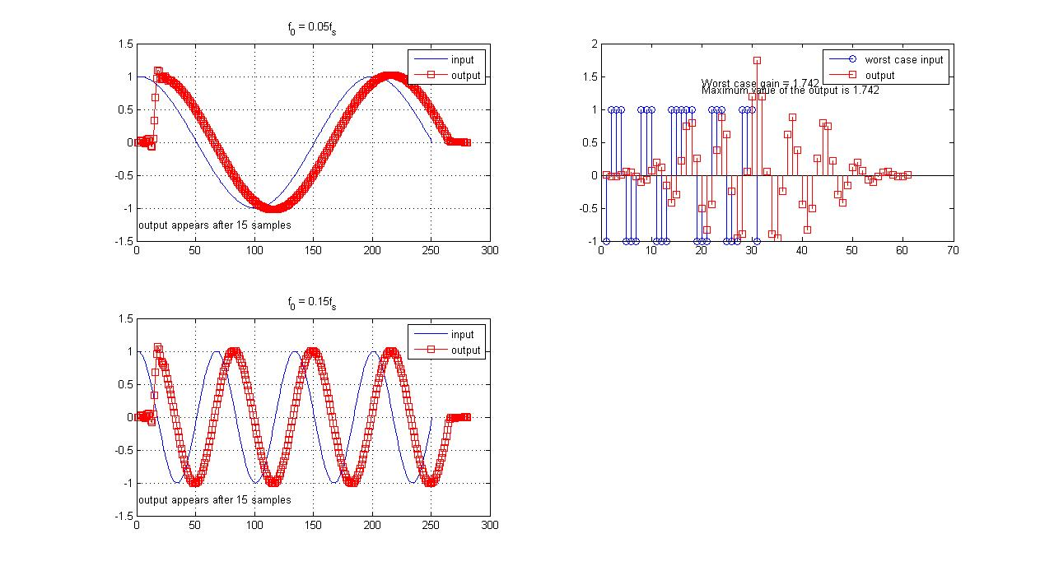Fig 11: Three test inputs and outputs: two sinusoids and worst case input.
The above figure shows the three test inputs - two sinusoids and a worst case input. The first sinusoid has a frequency of 0.05fs and the second one has a frequency of 0.15fs. Both the sinusoid, irrespective of their frequencies, appear at the output only after 15samples which is the group delay of the filter.
The worst case input can be defined as the sign(h_k). When sent through the filter, a value through the middle of the convolution shoots to the worst case gain of the filter which is 1.742.
Part V
Part VI, Experimentation
The signal model is as explained in the figure above. The key steps are:
x_k = W(k - n N_s)[Acos(2pi fc/fs k + phi_1n) + Asin(2pi fc/fs k + phi_2n)];
where x_k is the series of values that leave the transmitter, W(k-n*N_s) is a window of length N_s which is moved over to a new location N_s samples away with every new symbol. N_s is the duration, in number of samples, of each QPSK symbol. N_s can be readily shown as fs/fQPSK. phi_1n and phi_2n contain the data.
phi_1n = {0, pi} and phi_2n = {0, pi}; together they represent 2 bits or 4 symbols.
y_k_unsync = h_k * (x_k + n) where n is the noise(Gaussian).
Samples are meaningful only from the 16th sample onwards due to the delay induced by the front end filter.
Symbols are then extracted from the received time series and are projected on to the basis vectors which give the components present on them and are appropriately mapped to bits. These demodulated bits are then compared with the transmitted bits to measure
BER = #error bits/total bits.
The following is the BER plot over an SNR range from 0dB to 15dB

